**DOCUMENTATION FOR MVC APPLICATION (TECHNEAI)**

MVC Application developed in asp.net framework

Using ADO.NET database framework.

1. Front page displaying Customer details and items details

Date is current and bill is autogenerated

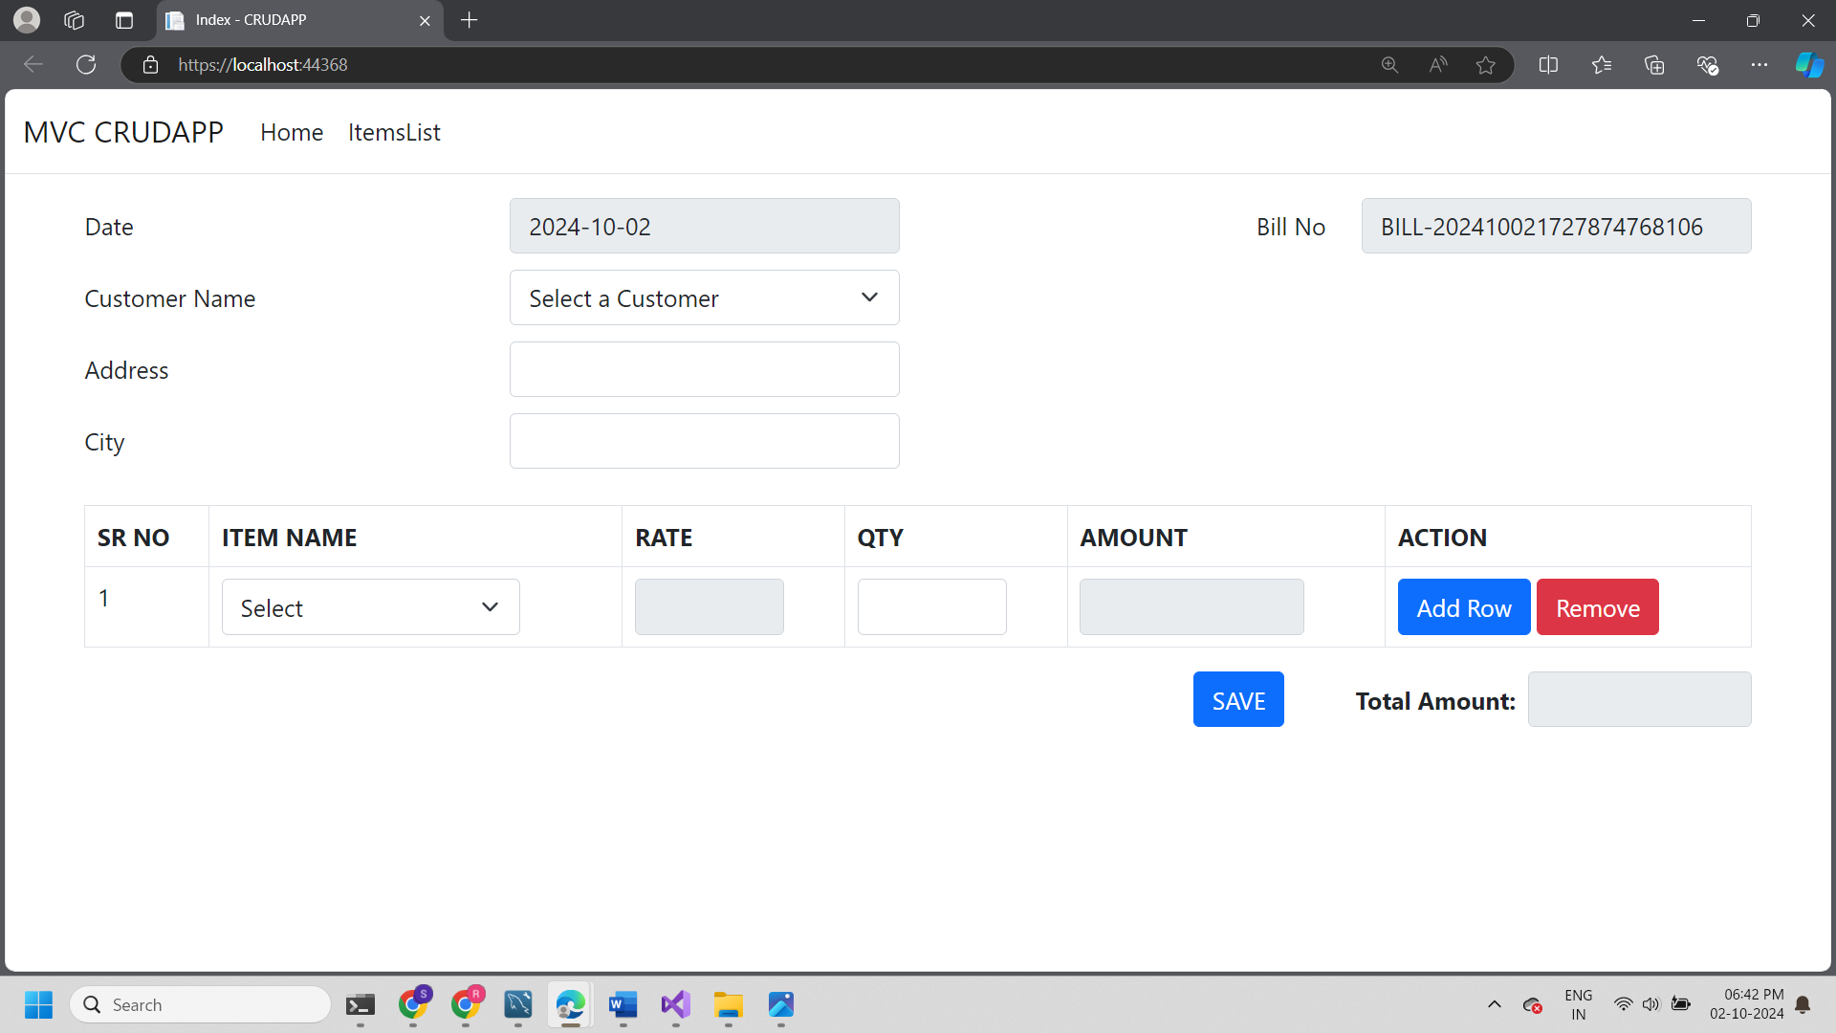

1. Displaying dropdown list for customer based on that city and address populated

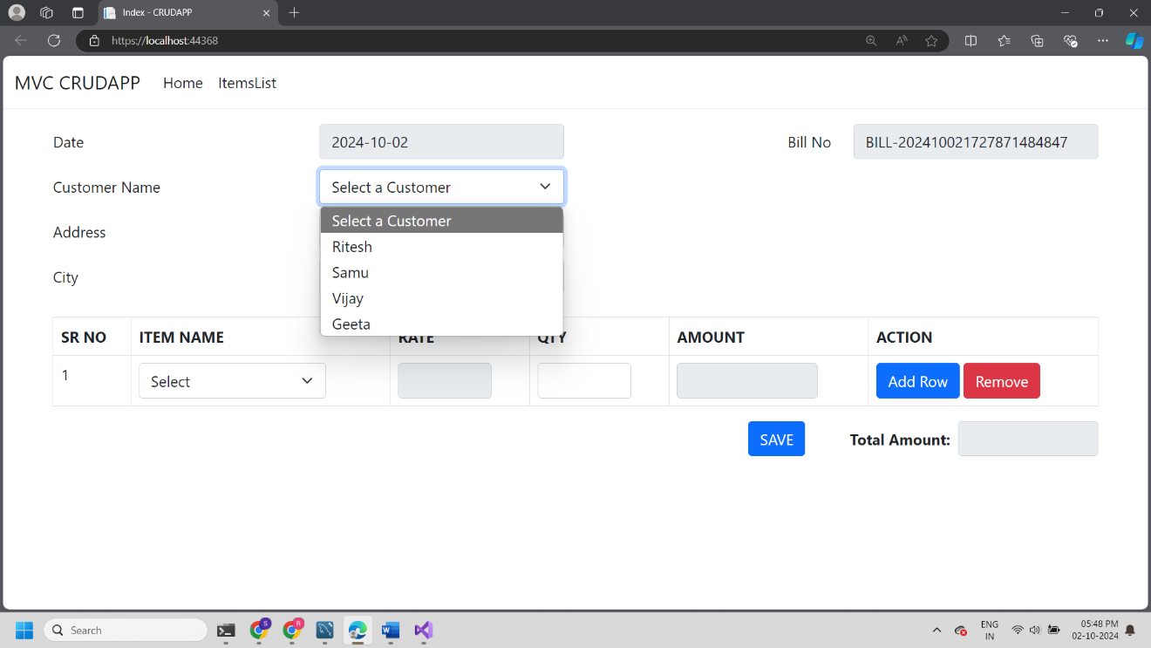

1. Displaying dropdown list for item name based on that rate is populated

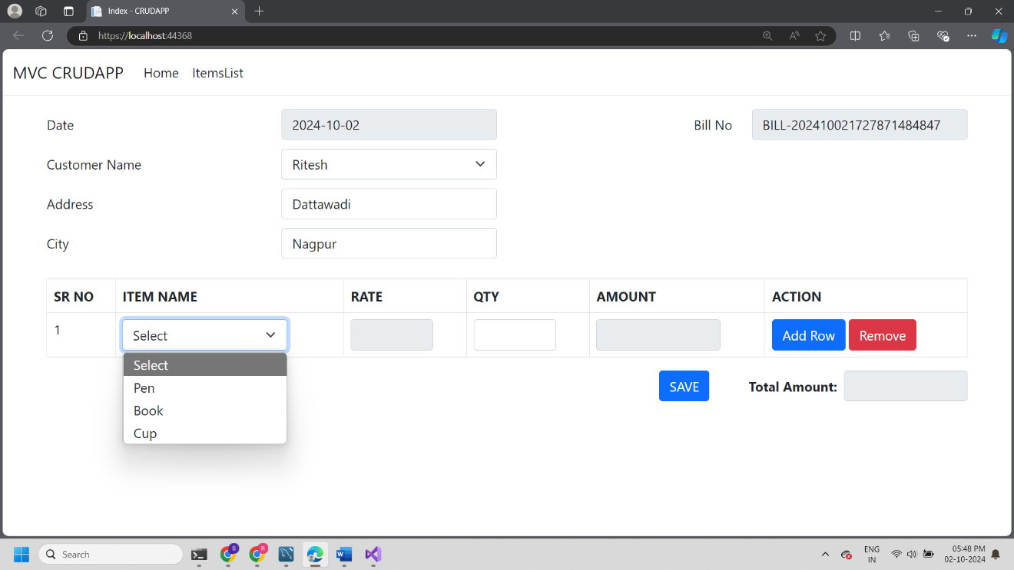

1. After adding details and quantities total amount is calculated

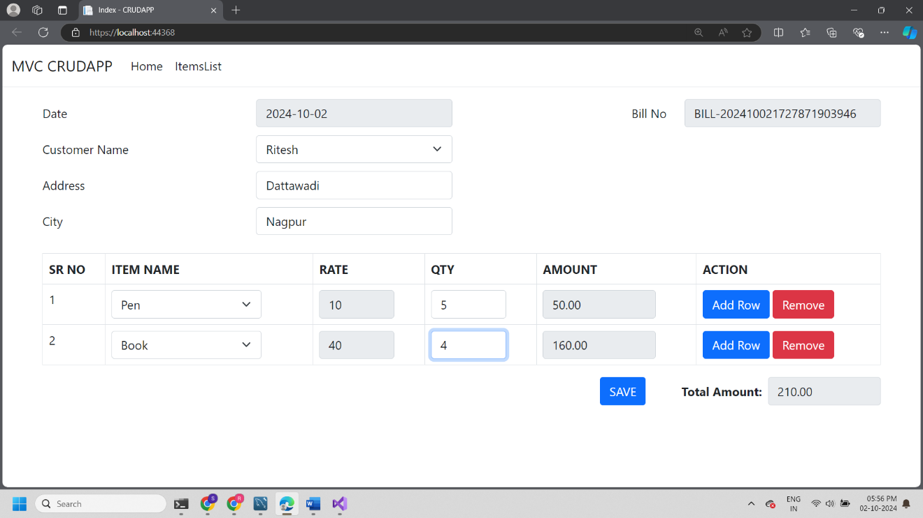

1. After clicking submit button data is saved in database.

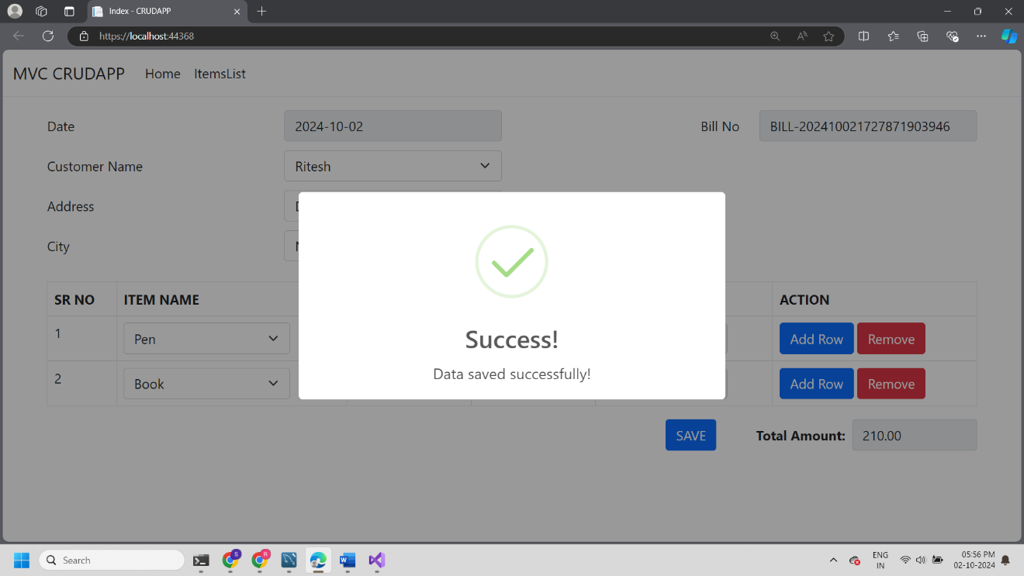

1. Item_master table

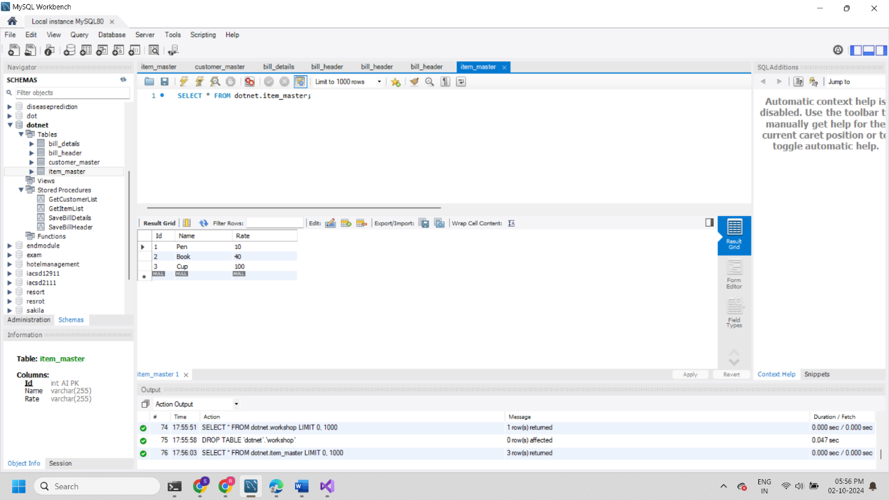

1. Customer_master table

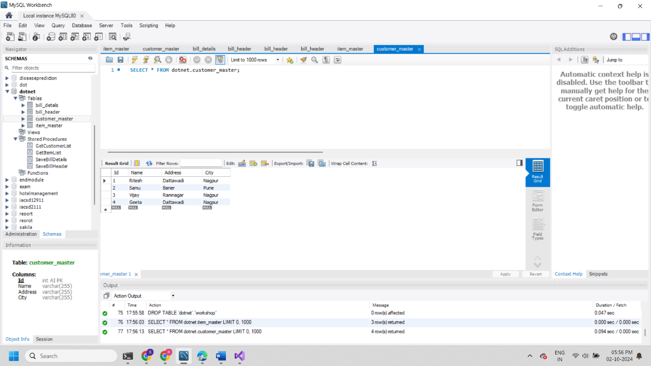

1. Bill_header table

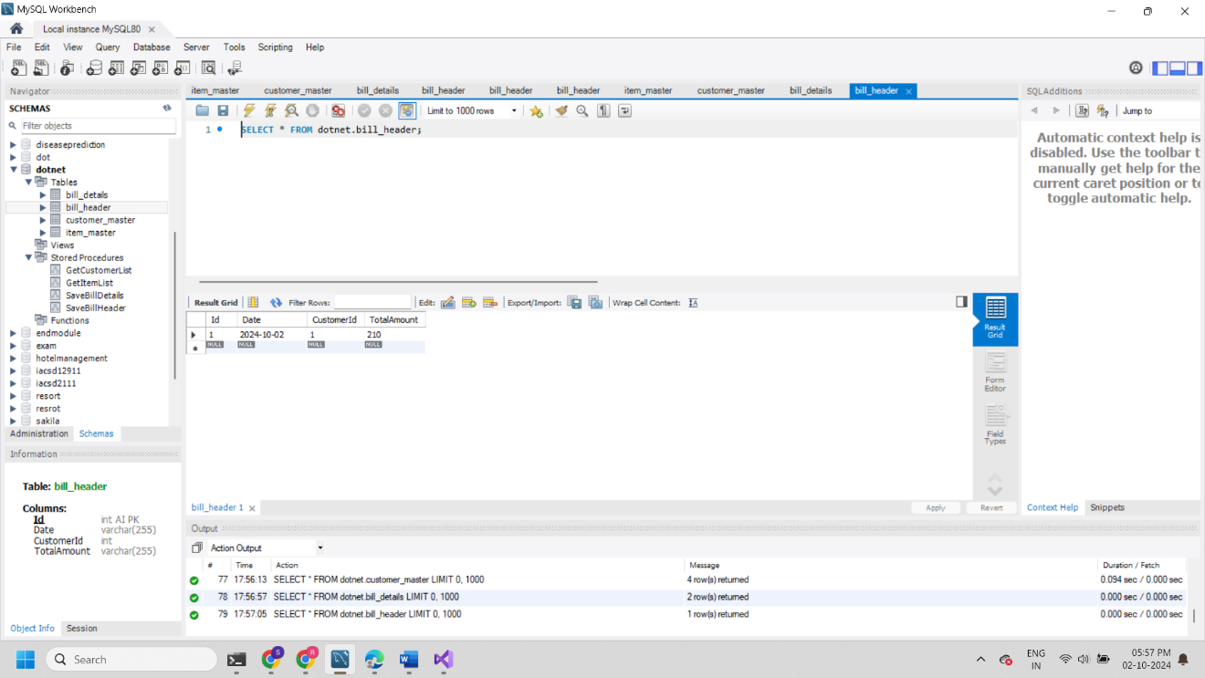

1. Bill_details table

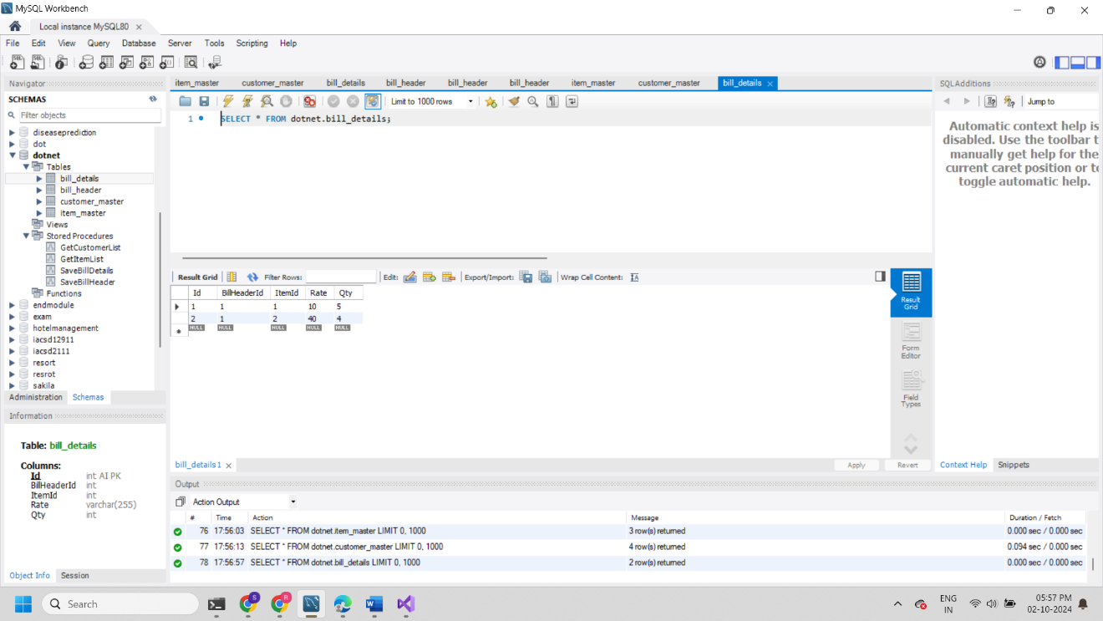

1. Created 4 sp’s to store and retrieve data from database

GetCustomerList;

SaveBillHeader;

SaveBillDetails;

GetItemList;

1. Backend db connection to connect and sp call

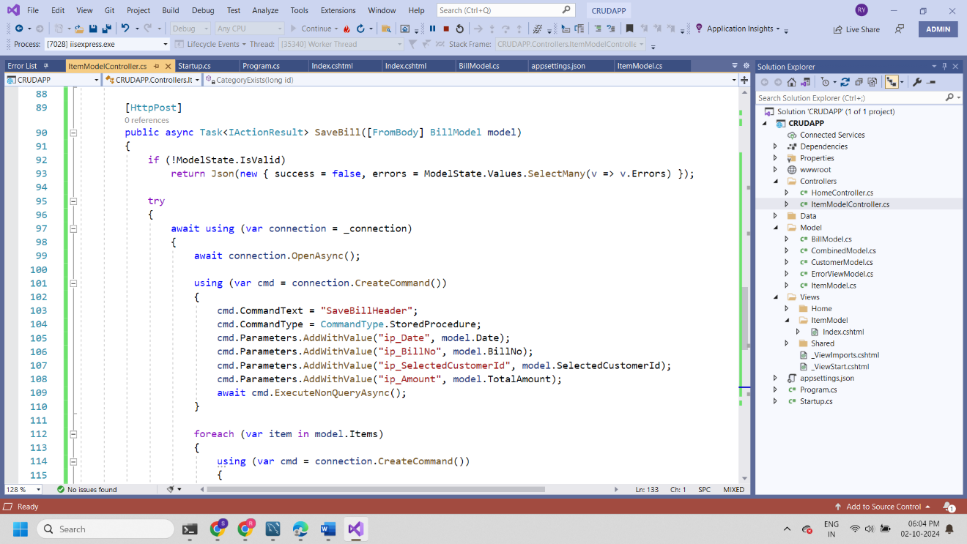

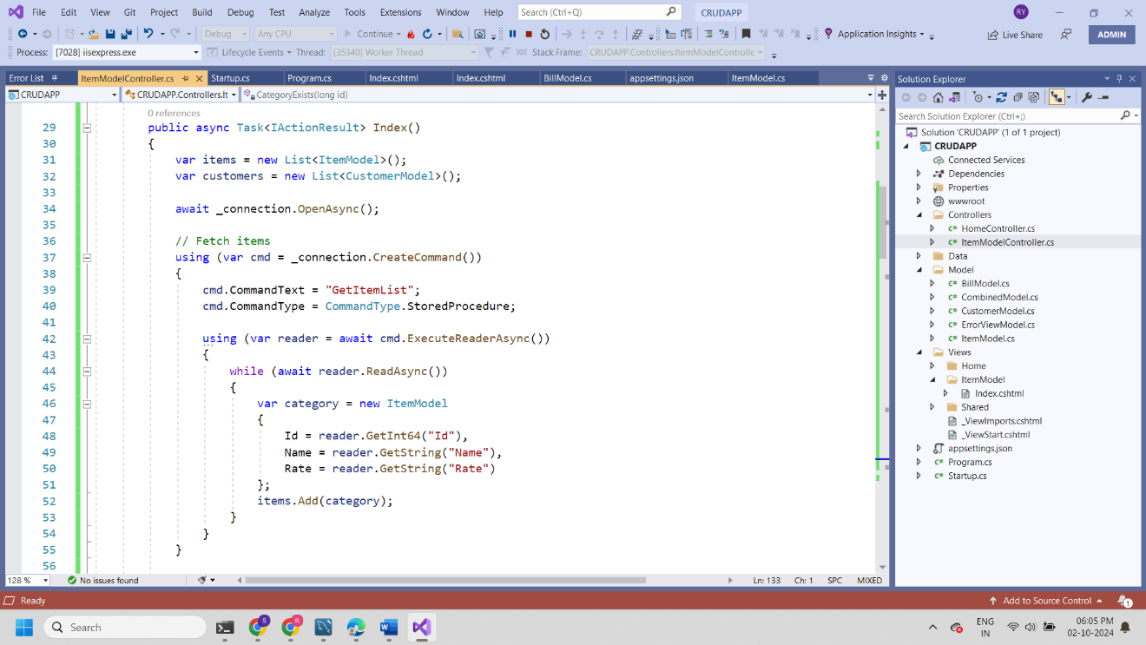

Thanks Ritesh Yawale (8390150577)

Test Paper

**Table name customer master and Fields**

**Table name item master and Fields**

ID - .........

Name- ...........

Rate - .............

ID - .........

Name- ........…

Address-………..

City-………….

**Table name bill header**

**Table name bill details**

ID …………

Date …………

Customer ID ………….

Total Amount …………

ID …………

Bill header ID …………

Item ID ………….

Rate …………

QTY …………..

|  |  |  |  |  |  |  |  |  |  |  |  |  |  |  |  |  |  |  |  |  |  |  |  |  |  |  |  |  |  |  |
| --- | --- | --- | --- | --- | --- | --- | --- | --- | --- | --- | --- | --- | --- | --- | --- | --- | --- | --- | --- | --- | --- | --- | --- | --- | --- | --- | --- | --- | --- | --- |
| Date Bill no  Customer Name  Address  City   |  |  |  |  |  |  | | --- | --- | --- | --- | --- | --- | | Sr.no | Item | Rate | Qty | Amount | Action | | 1 | Item 1(Drop Down) | 100 | 2 | 200 | + | | 2 | Item 2 (Drop Down) | 300 | 3 | 900 | - | |  |  |  |  |  |  | |  |  |  |  |  |  |     Total Amount  **Save** |

Generate a form as shown above,

it is having date as today's date , bill no as auto incremented bill no.

1. Customer name(Drop Down), address and city will get fetch from Customer master. When Customer is selected then fetch address and city and auto fill
2. Below is the area having item details of bill no:

When Select the item name (Drop down) then fetch rate form item master.

Qty is user defined amount will get calculated as rate * qty.

1. Action column showing + add button - button on click event of these button new records will get added or subtracted respectively.
2. Click on save then save data in bill header and Bill Detatils
3. Insert Data In Customer Master and item master (Hardcoded value).

Create this project on your localhost.

-- Try to complete this test in C# MVC

-- Do not use Entity Framework (Write your own query or Stored procedure)

After Complete Test submit your working source code (Entire Solution in Zip Format) and Database script along with your resume to.

[hr@techneai.com](mailto:hr@techneai.com) And [baliram.rajwad@techneai.com](mailto:baliram.rajwad@techneai.com)